EXPT NO:3 | CLEANSE DATA BY HANDLING MISSING VALUES, OUTLIERS, AND INCONSISTENCIES USING TABLEAU AND POWERBI
DATE: 10.07.2026

PRE-LAB QUESTIONS :
- What are the potential impacts of missing values in a dataset, and what are some common strategies to address them in Tableau and Power BI?

Missing values reduce the accuracy and reliability of data analysis and may produce incorrect insights. They can also affect visualizations and predictive models. In Tableau and Power BI, missing values can be handled by replacing them with the mean, median, or a default value such as "Unknown" using built-in data cleaning features.

- What is the importance of identifying and addressing outliers in a dataset? How can outliers affect data analysis and model performance?

Outliers are extreme values that differ significantly from the rest of the data. They can distort averages, trends, and statistical analysis, leading to inaccurate results. Identifying and treating outliers improves data quality and helps create more reliable visualizations and machine learning models

- What types of data inconsistencies might you encounter during data cleansing, and how can Tableau and Power BI help in resolving them?

Common inconsistencies include duplicate records, inconsistent text values, incorrect date formats, and spelling variations. Tableau and Power BI provide tools like Group, Alias, Replace Values, and Power Query to standardize and correct these inconsistencies, ensuring uniform and accurate data.

- How do you identify patterns in data using visualizations to spot missing values, outliers, and inconsistencies?

Visualizations such as scatter plots, box plots, histograms, and bar charts help identify unusual patterns in the data. Missing values, outliers, and inconsistent categories become easier to detect through these charts. This allows users to clean the data effectively before performing analysis.

- What is the role of calculated fields in data cleansing, and how can they be used to handle missing values and outliers in Tableau/Power BI?

Calculated fields automate data cleaning by replacing missing values, creating default values, and flagging outliers. Functions like IFNULL() in Tableau and IF(ISBLANK()) in Power BI simplify the cleaning process. They also help maintain consistency without modifying the original dataset

IN-LAB EXERCISE:
OBJECTIVE:
To clean a given dataset (e.g., Superstore Sample in Tableau and Financials/Sales Data in Power BI) by identifying and resolving missing values, outliers, and inconsistencies using built-in tools, ensuring the dataset is accurate and ready for analysis.
PROCEDURE:
  - Open the Tool and Connect Dataset o Open Tableau Desktop , Power BI Desktop.
    - Load the built-in dataset (Sample - Superstore in Tableau / Financials in Power BI).
    - Preview the dataset to understand its structure.
  - Initial Inspection o Explore fields such as Sales, Profit, Region, or Product Category.
    - Check for nulls, inconsistent text values (e.g., "South Region" vs. "South"), or date formatting issues.
  - Handling Missing Values o Use Data Interpreter (Tableau) / Power Query (Power BI) to highlight nulls. o Replace missing numerical values with mean/median, and text with "Unknown".
    - Use calculated fields: IFNULL([Field], Default) in Tableau or IF(ISBLANK([Field]), "Unknown", [Field]) in Power BI.
  - Detecting and Managing Outliers o Create scatter or box plots for Sales and Profit to identify extreme values.
    - Choose strategies:
      - Filter them temporarily.
      - Apply caps using calculated columns.
      - Flag them with labels for review.
  - Resolving Inconsistencies o Use Group/Alias (Tableau) / Replace Values (Power BI) to standardize text.
    - Normalize data formats, such as date fields or currency units.
- Validation with Visuals
    - Build dashboards with histograms, bar charts, and box plots to visually confirm improvements.
    - Compare before/after cleaning stages for accuracy.
- Save the Cleaned Dataset o Save as .twbx (Tableau) / .pbix (Power BI).
o Optionally export cleaned data to .csv.
- Summary Dashboard
o Create a visual summary of the cleaning process, highlighting:
      - Fields corrected.
      - Nulls/outliers removed or adjusted.
      - Clean dataset metrics (record count, completeness %).

Experiment Dataset:
  - Tableau: Sample - Superstore
  - Power BI: Financials or Sales Data
How to Access:
Tableau:
  - Navigate to: Start Page → Sample Workbooks
  - Or: Help → Sample Data → Open Sample Data Folder

Power BI:
  - Navigate to: Home → Get Data → Excel → Choose sample datasets (e.g., Financial Sample.xlsx)
  - Microsoft also hosts Power BI sample datasets online.
Fields Used:
  - Sales
  - Profit
  - Region
  - Category
  - Order Date / Transaction Date
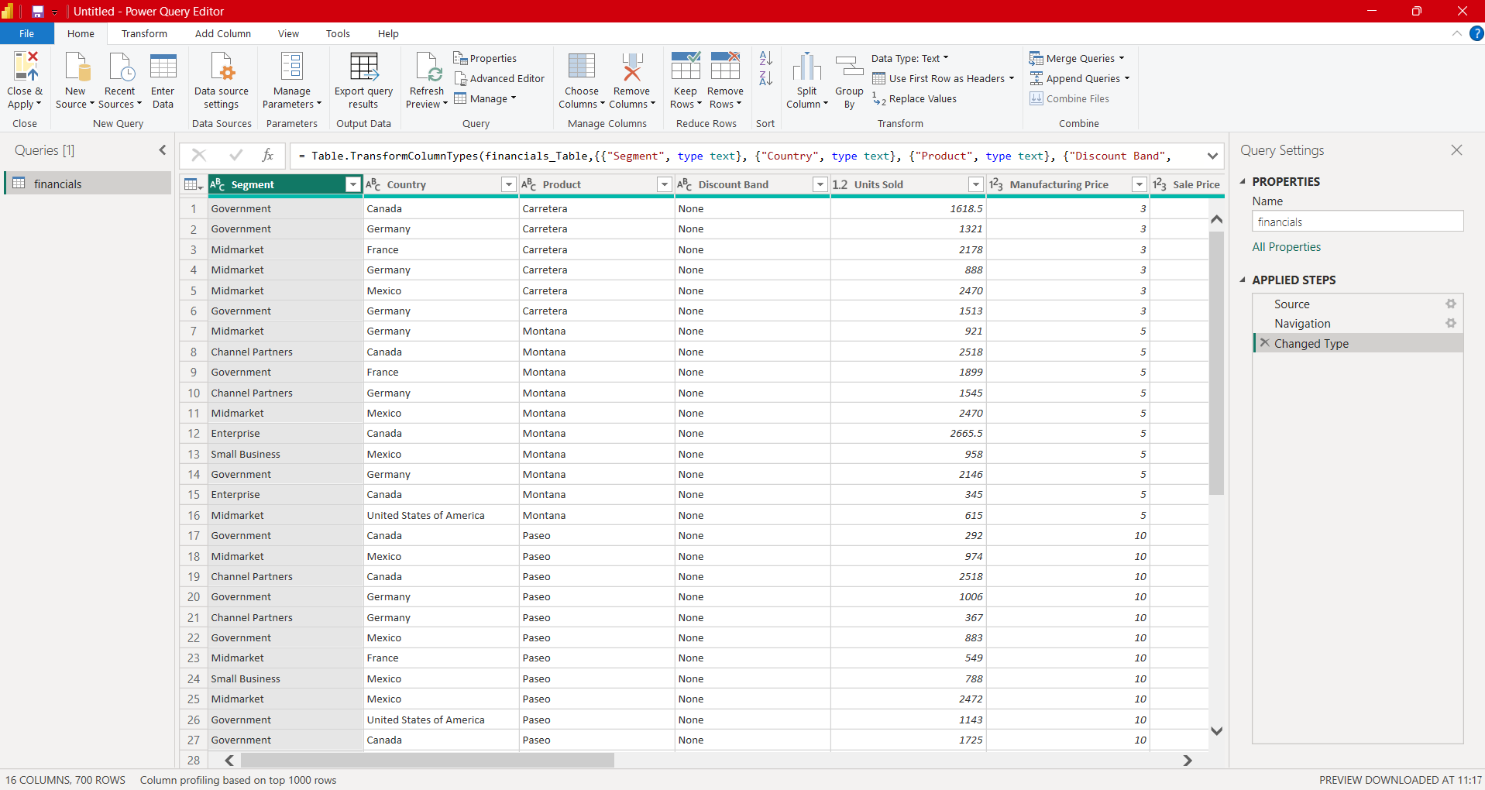
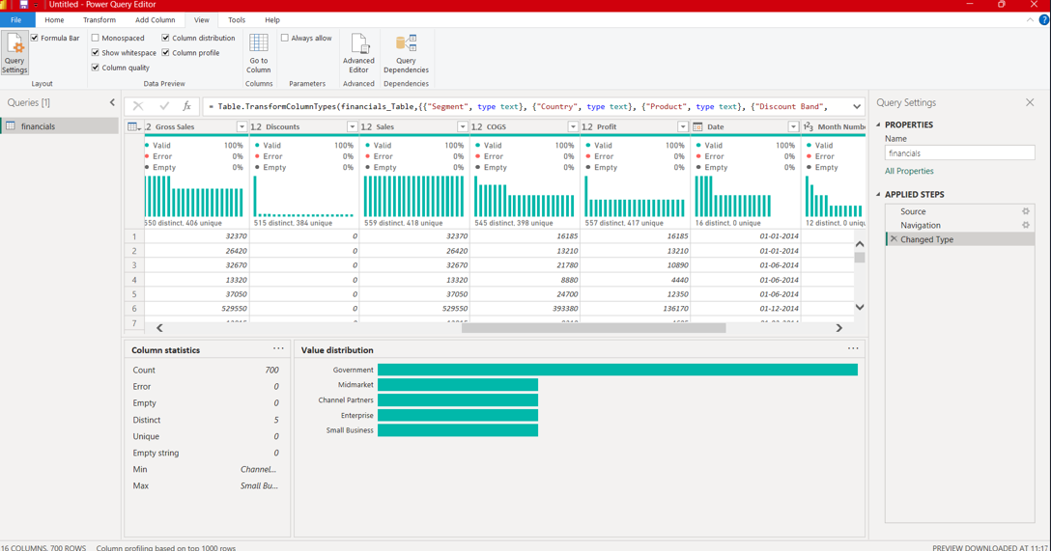
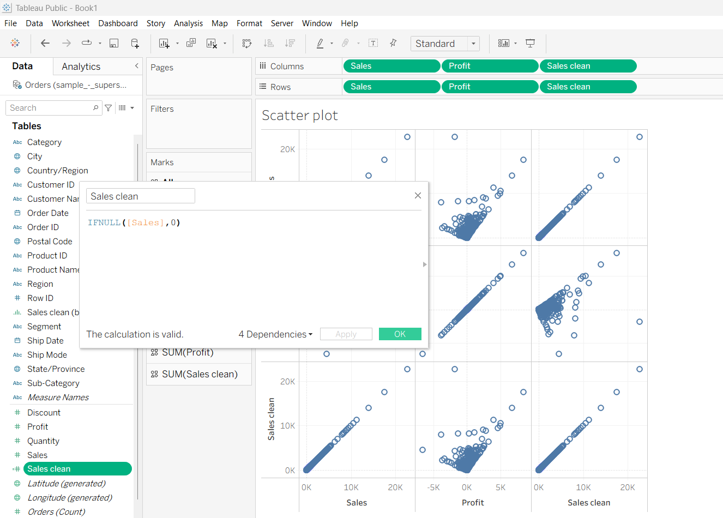
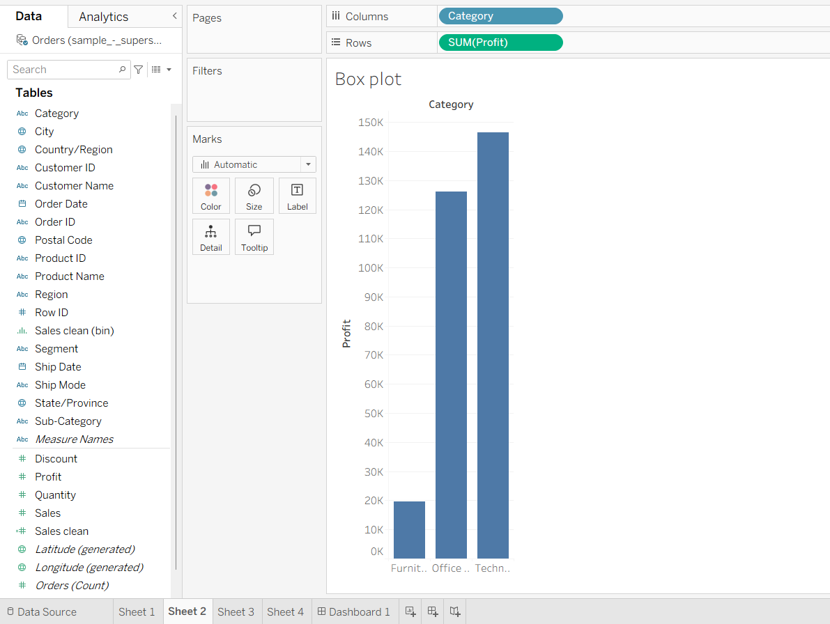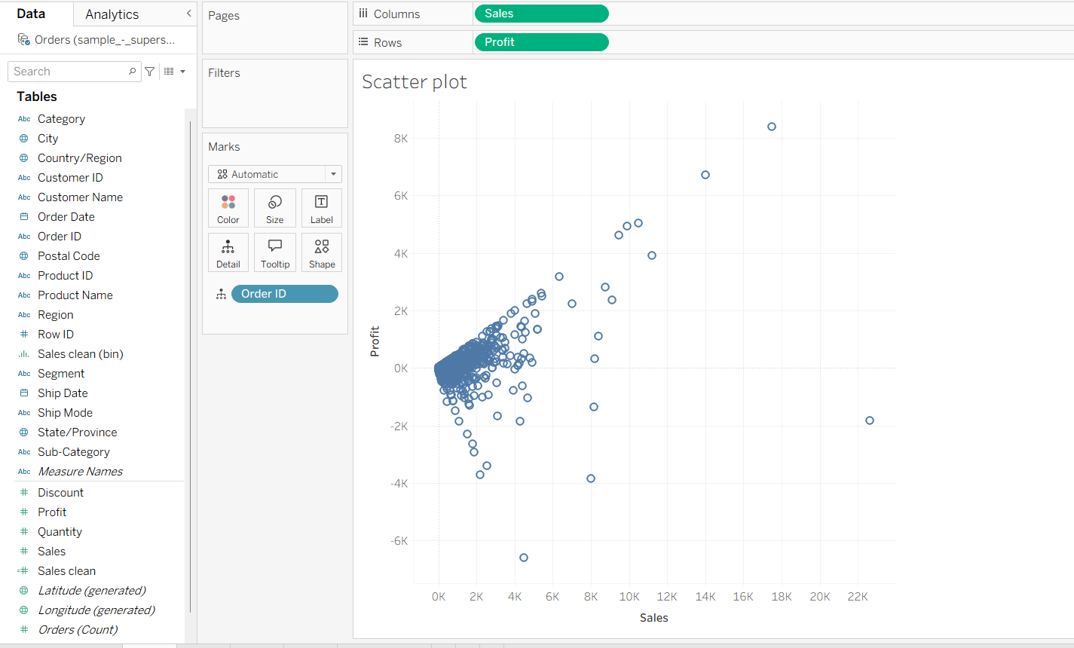
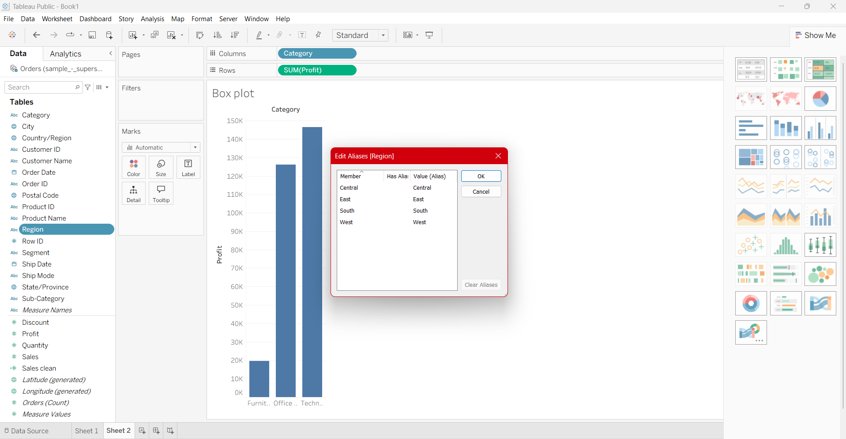
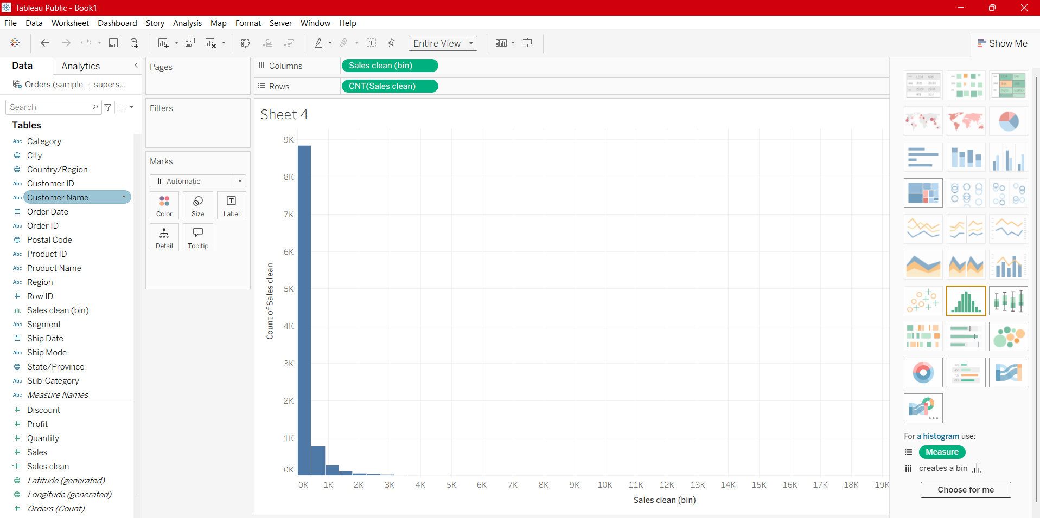
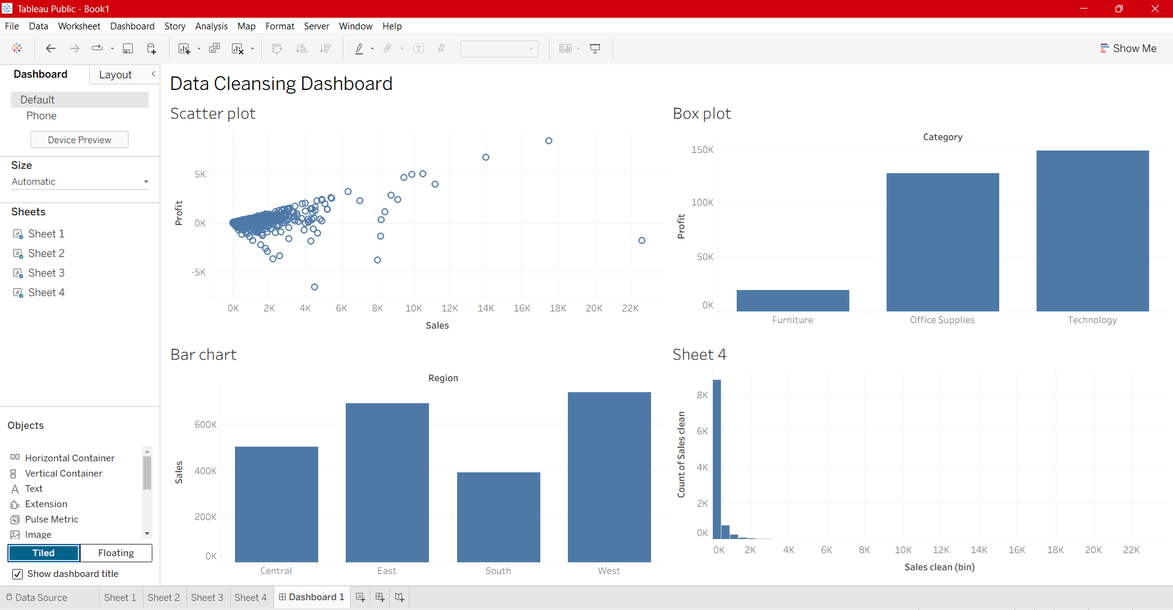
POWERBI: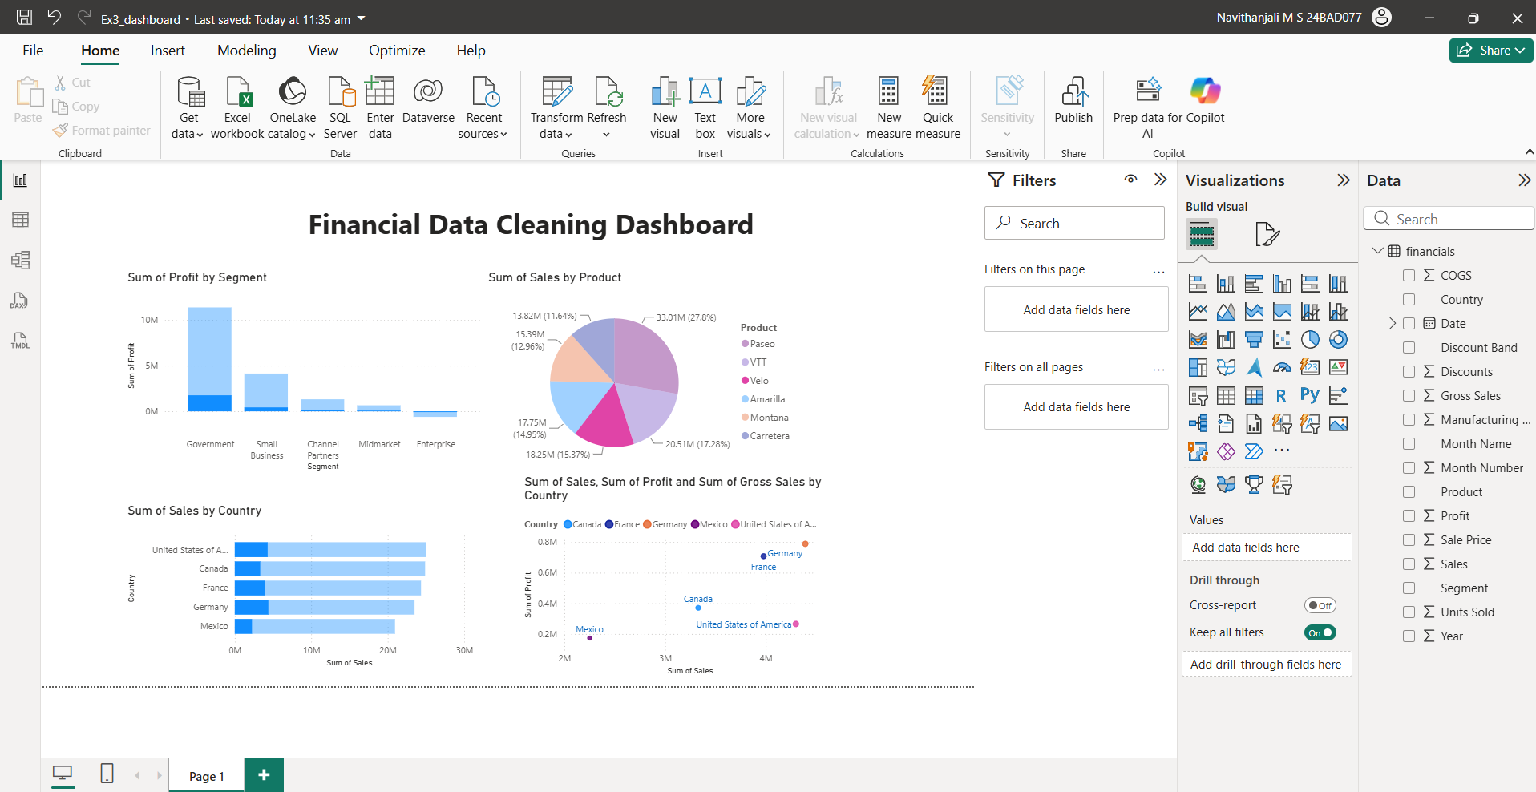

POST-LAB QUESTIONS :
- What method did you use to replace missing values in numeric fields?

Missing numeric values were replaced using the mean or median of the respective column. This method preserves the overall distribution of the data and minimizes the impact of missing information. It ensures that further analysis can be performed without losing records.

- How were outliers handled in your dataset and what visual confirmed their correction?

Outliers were identified using scatter plots and box plots. They were either filtered, capped, or flagged for review depending on their significance. The updated visualizations confirmed that extreme values were managed effectively without affecting overall trends.

- What inconsistencies were detected in categorical values and how were they standardized?

The dataset contained inconsistent category names, spelling differences, and formatting issues. These were standardized using Group/Alias in Tableau or Replace Values in Power BI. This ensured that similar categories were represented uniformly across the dataset.

- Describe how calculated fields helped in resolving data issues.

Calculated fields were used to replace missing values, assign default values, and identify outliers automatically. Functions such as IFNULL() and IF(ISBLANK()) simplified the cleaning process. They improved consistency while preserving the original data

- How did your dashboard demonstrate the effectiveness of the data cleaning process?

The dashboard displayed charts and metrics comparing the dataset before and after cleaning. It showed reduced missing values, standardized categories, and properly managed outliers. This confirmed that the dataset was clean, consistent, and ready for accurate analysis

RESULT:

The dataset was successfully cleaned and prepared for accurate analysis using Tableau and Power BI. Issues such as nulls, inconsistencies, and outliers were identified and resolved, improving data quality significantly.

ASSESSMENT

Description |  | Max Marks | Marks Awarded
Pre Lab Exercise |  | 5
In Lab Exercise |  | 10
Post Lab Exercise |  | 5
Viva |  | 10
 | Total | 30
 |  | Faculty Signature

